PROCEDURE

1. Create and invoke the ADD_JOB procedure and consider the results.

a. Create a procedure called ADD_JOB to insert a new job into the JOBS table. Provide the ID and title of the job, using two parameters.

b. Compile the code, and invoke the procedure with IT_DBA as job ID and Database
Administrator as job title. Query the JOBS table to view the results.



CREATE PROCEDURE ADD_JOB(Id IN jobs.job_id%type,title IN jobs.job_title%type) IS
BEGIN
INSERT INTO JOBS values(Id,title,'1222','123');
END;
EXECUTE ADD_JOB('IT_DBA','Database Administrator');

2. Create a procedure called UPD_JOB to modify a job in the JOBS table.
a. Create a procedure called UPD_JOB to update the job title. Provide the job ID and a new title, using two parameters. Include the necessary exception handling if no update occurs.

b. Compile the code; invoke the procedure to change the job title of the job ID IT_DBA to Data Administrator. Query the JOBS table to view the results.

Also check the exception handling by trying to update a job that does not exist (you can
use job ID IT_WEB and job title Web Master).

CREATE OR REPLACE PROCEDURE UPD_JOB(jobId jobs.job_id%type,title jobs.job_title%type) IS
counter jobs.max_salary%type :=0;
JOB_ID_NOT_FOUND EXCEPTION;
CURSOR C1 is select JOB_ID from JOBS;
BEGIN
FOR jobsid IN C1
LOOP
IF jobsid.job_id =jobId THEN
counter :=counter+1;
END IF;
END LOOP;
IF counter=1 THEN
update jobs
SET JOB_TITLE=title
WHERE JOB_ID=JOBID;
ELSE
RAISE JOB_ID_NOT_FOUND;
END IF;
EXCEPTION
WHEN JOB_ID_NOT_FOUND THEN
DBMS_OUTPUT.PUT_LINE('Job Id not found in Table');
END;
SET SERVEROUTPUT ON
EXECUTE UPD_JOB('IT_WEB','ADMINISTRATION_VICE_PRESIDENT');

3. Create a procedure called DEL_JOB to delete a job from the JOBS table.
a. Create a procedure called DEL_JOB to delete a job. Include the necessary exception
handling if no job is deleted.

b. Compile the code; invoke the procedure using job ID IT_DBA. Query the JOBS table to
view the results.



Also, check the exception handling by trying to delete a job that does not exist (use job ID
IT_WEB). You should get the message you used in the exception-handling section of the
procedure as output.

CREATE OR REPLACE PROCEDURE DEL_JOB(jobId jobs.job_id%type) IS
counter jobs.max_salary%type :=0;
JOB_ID_NOT_FOUND EXCEPTION;
CURSOR C1 is select JOB_ID from JOBS;
BEGIN
FOR jobsid IN C1
LOOP
IF jobsid.job_id =jobId THEN
counter :=counter+1;
END IF;
END LOOP;
IF counter=1 THEN
DELETE FROM JOBS WHERE JOB_ID=JOBID;
DBMS_OUTPUT.PUT_LINE('DELETED Job Id IS '||JOBID);
ELSE
RAISE JOB_ID_NOT_FOUND;
END IF;
EXCEPTION
WHEN JOB_ID_NOT_FOUND THEN
DBMS_OUTPUT.PUT_LINE('Job Id not found in Table');
END;
SET SERVEROUTPUT ON
EXECUTE DEL_JOB('IT_WEB');

4. Create a procedure called QUERY_EMP to query the EMPLOYEES table, retrieving the salary and job ID for an employee when provided with the employee ID.

a. Create a procedure that returns a value from the SALARY and JOB_ID columns for a
specified employee ID. Use host variables for the two OUT parameters salary and job ID.

b. Compile the code, invoke the procedure to display the salary and job ID for employee ID
120.
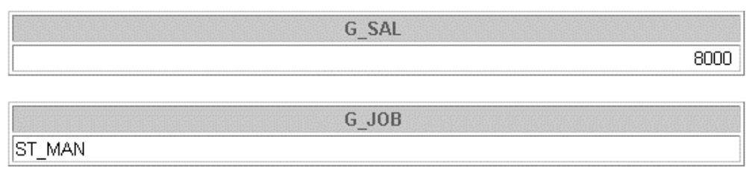

CREATE OR REPLACE PROCEDURE
QUERY_EMP(empId IN employees.employee_id%type,jobId OUT employees.job_id%type,EmpSalary OUT employees.salary%type) IS
BEGIN
SELECT SALARY,JOB_ID INTO EMPSALARY, jobId FROM EMPLOYEES where EMPLOYEE_ID=empId;
DBMS_OUTPUT.PUT_LINE('Salary is '||EMPSALARY||' and job id is '||jobId);
END;
/
SET SERVEROUTPUT ON
DECLARE
Ide employees.job_id%type;
sal employees.salary%type;
BEGIN
QUERY_EMP(120,IDE,SAL);
DBMS_OUTPUT.PUT_LINE('Annonnymous Block Salary is '||sal||' and job id is '||Ide);
END;

FUNCTION

1. Create and invoke the Q_JOB function to return a job title.
a. Create a function called Q_JOB to return a job title to a host variable.

CREATE OR REPLACE PROCEDURE add_job
(p_job_id IN jobs.job_id%TYPE,
p_job_title IN jobs.job_title%TYPE)
IS
BEGIN
INSERT INTO jobs(job_id, job_title) VALUES(p_job_id, p_job_title);
END add_job;
/

b. Compile the code; create a host variable G_TITLE and invoke the function with job ID
SA_REP. Query the host variable to view the result.

EXECUTE add_job('IT_DBA', 'Database Administrator');
COMMIT;



2. Create a function called ANNUAL_COMP to return the annual salary by accepting two
parameters: an employee’s monthly salary and commission. The function should address NULL
values.

a. Create and invoke the function ANNUAL_COMP, passing in values for monthly salary and
commission. Either or both values passed can be NULL, but the function should still
return an annual salary, which is not NULL. The annual salary is defined by the basic
formula:
(salary*12) + (commission_pct*salary*12)

b. Use the function in a SELECT statement against the EMPLOYEES table for department
80.
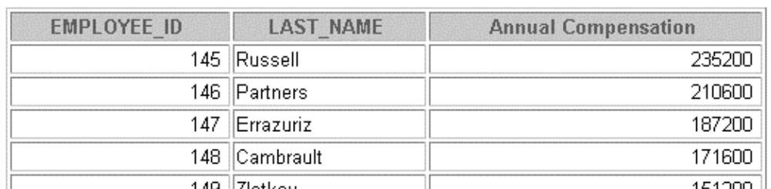

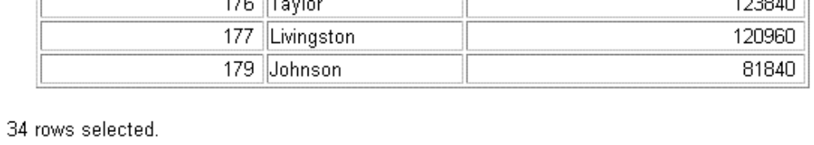

3. Create a procedure, NEW_EMP, to insert a new employee into the EMPLOYEES table. The
procedure should contain a call to the VALID_DEPTID function to check whether the
department ID specified for the new employee exists in the DEPARTMENTS table.

a. Create the function VALID_DEPTID to validate a specified department ID. The
function should return a BOOLEAN value.

CREATE OR REPLACE FUNCTION valid_deptid
(p_dept_id IN departments.department_id%TYPE)
RETURN BOOLEAN
IS
v_temp departments.department_id%TYPE;
BEGIN
SELECT department_id INTO v_temp
FROM departments WHERE department_id = p_dept_id;
RETURN TRUE;
EXCEPTION
WHEN NO_DATA_FOUND THEN
RETURN FALSE;
END valid_deptid;
/

b. Create the procedure NEW_EMP to add an employee to the EMPLOYEES table. A new
row should be added to the EMPLOYEES table if the function returns TRUE. If the
function returns FALSE, the procedure should alert the user with an appropriate message.
Define default values for most parameters. The default commission is 0, the default salary
is 1000, the default department number is 30, the default job is SA_REP, and the default
manager ID is 145. For the employee’s ID, use the sequence EMPLOYEES_SEQ. Provide
the last name, first name, and e-mail address of the employee.

CREATE OR REPLACE PROCEDURE new_emp
(p_first_name IN employees.first_name%TYPE,
p_last_name IN employees.last_name%TYPE,
p_email IN employees.email%TYPE,
p_department_id IN employees.department_id%TYPE DEFAULT 30,
p_phone_number IN employees.phone_number%TYPE DEFAULT NULL,
p_hire_date IN employees.hire_date%TYPE DEFAULT SYSDATE,
p_job_id IN employees.job_id%TYPE DEFAULT 'SA_REP',
p_salary IN employees.salary%TYPE DEFAULT 1000,
p_commission_pct IN employees.commission_pct%TYPE DEFAULT 0,
p_manager_id IN employees.manager_id%TYPE DEFAULT 145)
IS
e_invalid_department_id EXCEPTION;
BEGIN
IF valid_deptid(p_department_id) THEN
INSERT INTO employees(
first_name, last_name,
email, phone_number,
hire_date, job_id,
salary, commission_pct,
manager_id, department_id
) VALUES (
p_first_name, p_last_name,
p_email, p_phone_number,
p_hire_date, p_job_id,
p_salary, p_commission_pct,
p_manager_id, p_department_id
);
ELSE
RAISE e_invalid_department_id;
END IF;
EXCEPTION
WHEN e_invalid_department_id THEN
DBMS_OUTPUT.PUT_LINE('Error: ' || p_department_id || ' is an invalid department ID.');
END new_emp;
/

c. Test your NEW_EMP procedure by adding a new employee named Jane Harris to
department 15. Allow all other parameters to default. What was the result?

SET SERVEROUTPUT ON;
EXECUTE new_emp('Jane', 'Harris', 'janeharris@example.com', 15);

d. Test your NEW_EMP procedure by adding a new employee named Joe Harris to
department 80. Allow all other parameters to default. What was the result?

SET SERVEROUTPUT ON;
EXECUTE new_emp('Joe', 'Harris', 'joeharris@example.com', 80);

